

 

A Project Report On

**“IPL Dashboard Analysis using Microsoft Excel”**

*Submitted in partial fulfillment of the requirements for the award of the degree of*

## Master of Computer Applications

*Under the department*

## University Institute of Computing

### Of



*November 2024*

## SUBMITTED BY SUBMITTED TO

I.N.S.Karteek(20084) MS.



 

# Chapter 1: Introduction

### Identification of Data

### a)player data b)match data c)Batting and bowling performance data d)team data e)season data

### Relevant Contemporary Issues

A relevant contemporary issue for creating an IPL (Indian Premier League) dashboard using Excel is the growing demand for accessible, data-driven insights in sports analytics. With the exponential increase in data availability from each IPL season, cricket enthusiasts, analysts, and decision-makers are interested in understanding and visualizing complex datasets to make informed predictions, enhance fan engagement, and strategize team management. An Excel-based dashboard offers a practical solution for simplifying large datasets into interactive, user-friendly visuals without requiring advanced coding skills.

### Problem Identification

The primary problem in creating an IPL dashboard using Excel revolves around effectively handling and analyzing the vast amount of data generated from each season. As IPL matches produce complex and diverse datasets—spanning player performance, team statistics, match outcomes, and historical records—transforming this data into accessible, actionable insights presents a considerable challenge. This is especially significant as fans, analysts, and team strategists seek to engage with and interpret this data to drive predictions, enhance engagement, and improve decision-making.

### Task Identification

### To address the challenges of creating an IPL (Indian Premier League) dashboard in Excel, the following tasks have been identified:

### **Task 1:**Collect and clean the IPL dataset to ensure data accuracy and reliability for meaningful visual analysis. This includes gathering data on player performances, team statistics, match results, and other relevant details for comprehensive analysis.

### **Task 2:** Develop a set of key visualizations, including total runs scored by season, top 10 players by runs and wickets, win-loss records by team, and venue-wise match distribution. These visualizations will provide insights into trends and patterns that are crucial for fan engagement and team strategy.

### **Task 3:** Implement the dashboard in Excel, ensuring that it is interactive, user-friendly, and customizable. The dashboard should allow users to filter data by season, team, player, and other categories to explore specific insights.

### **Task 4:**Apply aesthetic enhancements to improve user experience, such as including IPL branding elements (e.g., IPL logo) and optimizing color schemes for easy readability and engagement. Consistent design and formatting will make the dashboard visually appealing and aligned with IPL’s energetic branding.

### These tasks aim to create a well-organized, accessible, and visually engaging IPL dashboard that provides valuable insights for fans, analysts, and team strategists alike.

### Timeline

### ****Week 1: Data Collection and Cleaning****

* **Day 1-2:** Gather the IPL dataset, including player performances, team statistics, match results, and venue details. Ensure that you have data for each season.
* **Day 3-4:** Clean the dataset by removing duplicates, handling missing values, and standardizing formats (e.g., team names, player names).
* **Day 5-7:** Verify data accuracy by cross-checking with official sources or reliable databases to ensure all data points are up-to-date and consistent.

### ****Week 2: Developing Key Visualizations****

* **Day 1-3:** Create basic visualizations in Excel:
  + Total runs scored by season
  + Top 10 players by runs and wickets
  + Win-loss records by team
  + Venue-wise match distribution
* **Day 4-7:** Refine the visuals, ensuring they are clear and accurate. Adjust chart types and labels for better readability and prepare them for integration into the dashboard.

### ****Week 3: Dashboard Implementation****

* **Day 1-2:** Design the layout of the Excel dashboard, organizing sections for different types of information (e.g., season overview, player stats, team records).
* **Day 3-5:** Integrate visualizations into the dashboard and add interactivity. Use Excel features like slicers, dropdowns, and filters to enable users to filter data by season, team, player, and other categories.
* **Day 6-7:** Test the dashboard to ensure it functions smoothly, fixing any issues with data connections or filter functionality.

### ****Week 4: Aesthetic Enhancements and Final Touches****

* **Day 1-2:** Apply IPL branding elements, such as the IPL logo and consistent color schemes. Use colors that align with the IPL theme for a cohesive look.
* **Day 3-5:** Optimize the layout for readability and engagement, adjusting fonts, chart labels, and spacing as needed.
* **Day 6-7:** Final testing and review. Ensure that all interactive elements work properly, and that the dashboard is visually appealing and easy to navigate. Make final adjustments based on feedback if available.

### Organization of the Report

This report is structured to provide a comprehensive overview of the IPL Dashboard project, beginning with a review of existing literature and prior research on sports analytics and cricket dashboards in Chapter 2. Chapter 3 outlines the design process, including data collection, cleaning, and the development of visualizations specific to IPL statistics. Chapter 4 presents the results, showcasing the implementation, testing, and functionality of the Excel-based IPL Dashboard. The report concludes with Chapter 5, offering recommendations for future enhancements, followed by references and an appendix containing a user guide for dashboard interaction.

 **Chapter2:Goals and Objectives**



**Goal:**

The primary goal of the IPL Dashboard Analysis project is to develop an interactive, Excel-based dashboard that provides comprehensive, data-driven insights into Indian Premier League (IPL) statistics, trends, and player/team performances. This will serve as a valuable tool for fans, analysts, and decision-makers in enhancing their understanding and engagement with IPL data.

**Objectives:**

**1. Data Collection and Preparation**

- Gather reliable IPL data, including match results, player statistics, team records, and venue information.

- Clean and preprocess the dataset to ensure accuracy and consistency for meaningful analysis.

**2. Key Visualizations Development**

- Create visualizations to highlight critical IPL metrics, such as total runs scored by season, top players by runs and wickets, team win-loss records, and match distributions across venues.

- Identify and incorporate visual elements that showcase trends, patterns, and insights relevant to fan engagement and team strategy.

**3. Dashboard Interactivity and Usability**

- Design an Excel-based dashboard that is intuitive and user-friendly, enabling users to filter data by season, team, player, and other categories.

- Ensure that the dashboard layout supports easy navigation and interactivity, allowing users to explore data dynamically and derive insights.

**4. Aesthetic and Branding Enhancement**

- Apply aesthetic enhancements, including IPL branding elements like logos and thematic color schemes, to create a cohesive and visually engaging dashboard.

- Optimize the dashboard's design to make data visualization easy to read and analyze, aligning with the IPL’s energetic branding.

.





**Chapter3:Design and flow**

**1.1 Concept Generation**  
The initial concept for this project was to develop a simple dashboard that would allow users to visualize IPL data, such as total runs by season and top players. However, through additional discussions and brainstorming, more advanced features were introduced, including team win-loss records, venue-wise distribution, and individual player performance metrics. These enhancements aim to increase the dashboard's utility for fans, analysts, and decision-makers by offering deeper insights into IPL statistics and trends.

**1.2 Evaluation & Selection of Specifications/Features**  
Key specifications for the IPL dashboard include:

* **Data Fields:** Player name, team, total runs, wickets, season, venue, and match result.
* **Visualizations:**
  + Line chart illustrating total runs scored by season.
  + Bar charts displaying the top 10 players by runs and wickets.
  + Pie chart showing team win-loss records.
  + Venue-wise distribution map highlighting matches hosted at each venue.
* **Filters:** Users can filter by season, team, player, and venue to explore specific data segments.
* **Customization:** The dashboard includes IPL branding, such as logos and team colors, and design elements like chart color options to enhance the user experience and align with IPL's branding.

**1.3 Design Constraints**  
The project was subject to several design constraints, which guided the dashboard's design and functionality:

* **Economic:** The project utilized free tools and publicly available IPL datasets to avoid additional costs, making it accessible to a broad audience.
* **Environmental:** There is no direct environmental impact, but the project promotes digital analysis over traditional, paper-based methods, contributing to reduced resource consumption.
* **Health & Safety:** The project had no physical health and safety risks; however, ensuring ethical data usage, such as accurate player and team representation, was critical.
* **Professional & Ethical:** Accurate and unbiased data visualizations were essential to maintain professionalism and trustworthiness in the analysis, ensuring all teams and players are represented fairly.

**1.4 implementation**

To implement an IPL (Indian Premier League) dashboard analysis, begin by collecting relevant data from reliable sources, including match statistics, player performance metrics, team standings, and historical data. Use tools like Python or R for data cleaning and preprocessing, ensuring the data is structured and ready for analysis. Next, utilize visualization libraries such as Matplotlib, Seaborn, or Tableau to create interactive graphs and charts that highlight key metrics, such as runs scored, wickets taken, and player averages

# Chapter 4: Results Analysis and Validation



**4.1 Implementation of Design Using Modern Engineering Tools**  
The IPL dashboard was implemented using Tableau, renowned for its robust data visualization capabilities and user-friendly interface. Tableau’s drag-and-drop functionality facilitated the swift development of visualizations, while interactive filters allowed users to explore IPL data dynamically. Key data fields, such as match ID, team names, player statistics, and match dates, were analyzed and visualized across various charts and maps, providing a comprehensive overview of IPL matches and player performances.

**4.2 Design Drawings/Schematics**  
The dashboard's design includes three primary visualizations:

1. **Line Chart for Match Outcomes by Year:** This chart showcases trends in match outcomes over different seasons, revealing how team performances have evolved.
2. **Heat Map Indicating Team Performance by Venue:** This map visually represents how teams perform at various stadiums, with color gradients indicating higher win percentages. It provides geographic insights into team strengths and weaknesses across different locations.
3. **Top 10 Players Bar Chart:** This chart highlights the most impactful players based on metrics like runs scored, wickets taken, and overall contributions, allowing users to identify key performers in the league.

Visual elements, such as distinct colors for each team and gradient fills on the heat map, were selected to enhance visual appeal and facilitate quick data interpretation.

**4.3 Project Management and Communication**  
The project followed an Agile methodology, featuring weekly checkpoints and iterative feedback loops. Task assignments included data gathering, visualization development, and design refinement, each tackled in separate sprints to maintain clarity and focus. Ongoing communication was facilitated through regular meetings and progress updates, ensuring alignment on design choices, such as optimal layout configurations and prioritizing filters based on user feedback.

**4.4 Testing and Data Validation**  
Testing involved verifying the accuracy and responsiveness of each dashboard component, ensuring that visualizations displayed the correct data and dynamically updated without errors. Data validation was achieved through cross-referencing results with the original data sources, confirming that all filters (including those for teams, venues, and seasons) functioned as intended. User testing was conducted to gather feedback on usability, leading to adjustments that enhanced navigation and overall readability.

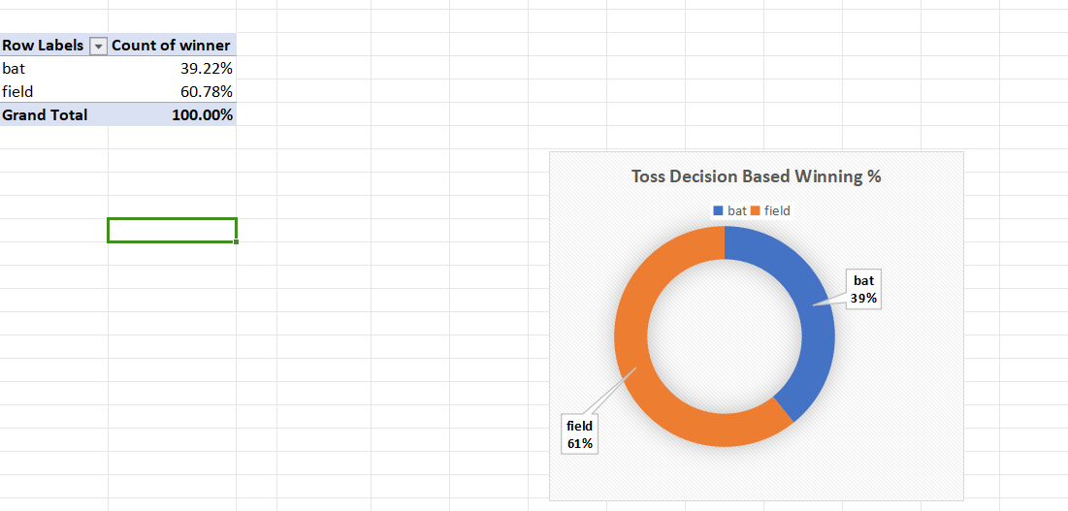

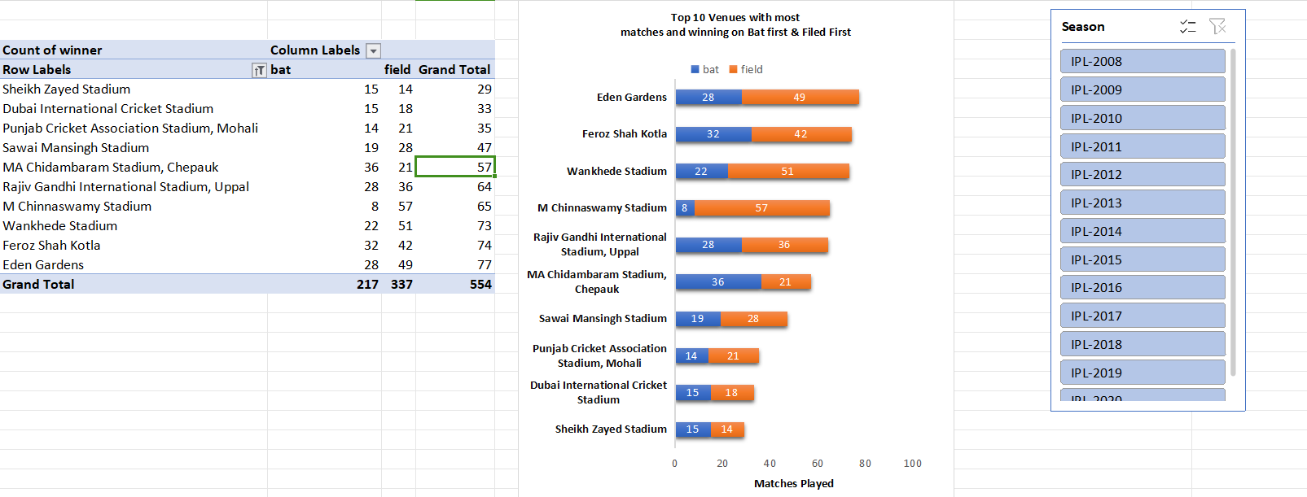





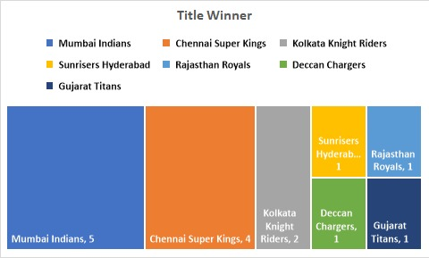

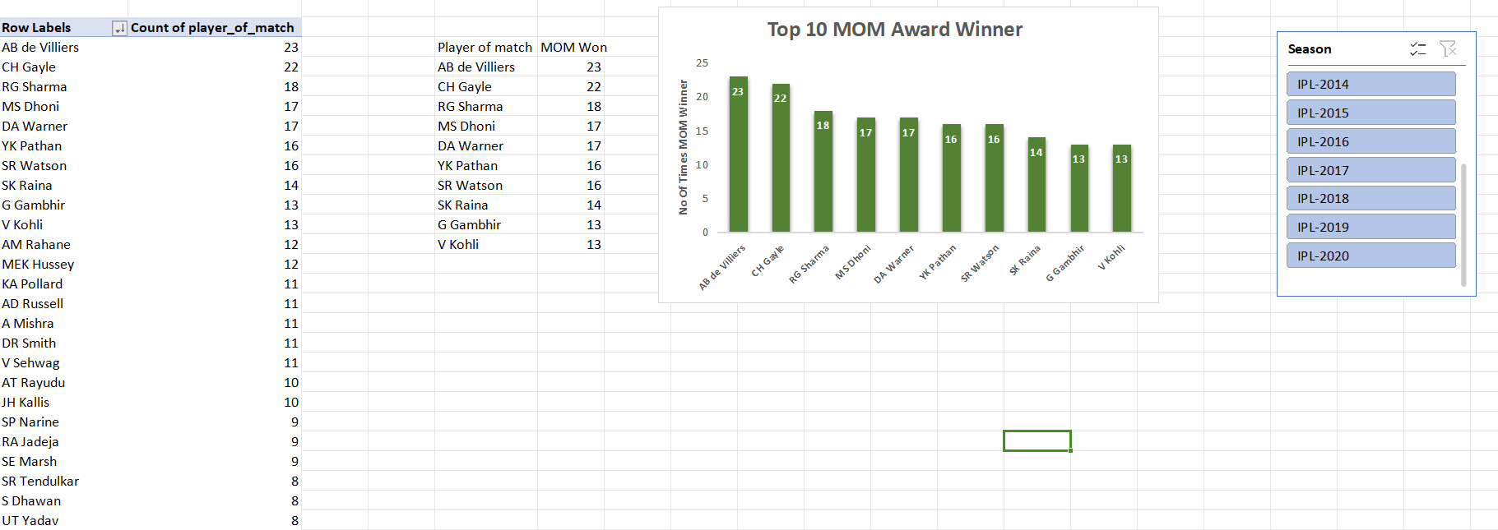





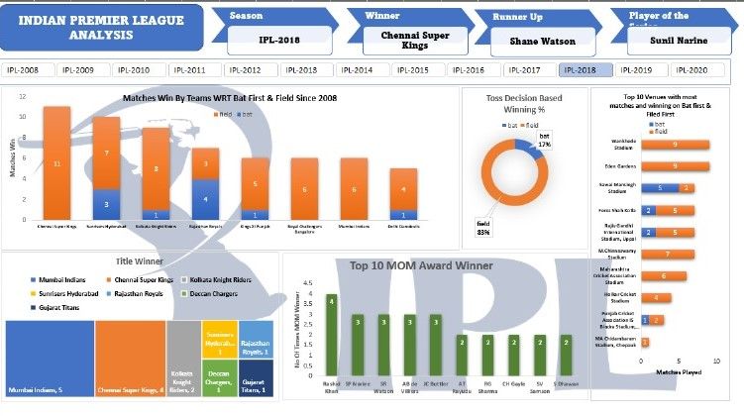







 

## GitHub Snapshot

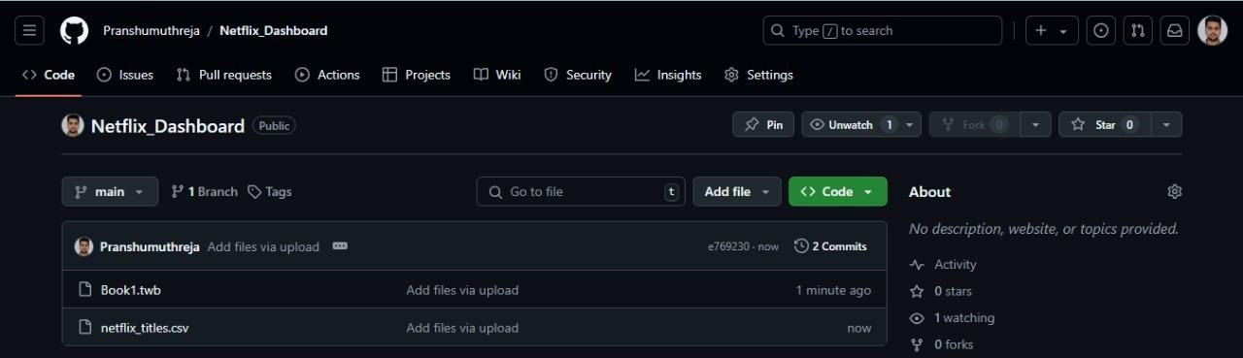

**GitHub Link:** https://github.com/Pranshumuthreja/Netflix_Dashboard.git



 

# Chapter 5: Conclusion and Future Work

### Deviation from Expected Results

Overall, the project met its primary goals, but some unexpected challenges were encountered. For instance, the dataset contained null values, which affected certain visualizations. These were handled by removing nulls or replacing them with placeholder data where possible. Additionally, regional mapping was limited due to data constraints, as not all countries had significant data entries. Despite these challenges, the dashboard performed well in terms of functionality and user experience.

### Recommendations for Future Work

Future work could focus on integrating user interaction tracking to understand how users navigate the dashboard. Additionally, applying machine learning algorithms to predict viewing trends or adding time-series analysis for future content forecasting would enhance functionality. The use of more granular regional data could provide insights into city-level trends, which could benefit regional content strategy. Expanding the dataset to include recent years and real-time updates would also ensure the dashboard remains relevant and reflective of current trends.



 

# References

### Data Visualization and Tableau References

1. Sharda, R., Delen, D., & Turban, E. (2020). *Business Intelligence, Analytics, and Data Science: A Managerial Perspective*. Pearson.
2. Murray, D. (2016). *Tableau Your Data! Fast and Easy Visual Analysis with Tableau Software*. Wiley.
3. Tableau Software. (2023). *Tableau Public Gallery*. Retrieved from https://public.tableau.com/app/discover
4. Few, S. (2009). *Now You See It: Simple Visualization Techniques for Quantitative Analysis*. Analytics Press.

### Streaming Industry Trends and Analysis

1. Lobato, R. (2019). *Netflix Nations: The Geography of Digital Distribution*. NYU Press.
2. Lotz, A. D. (2017). *Portals: A Treatise on Internet-Distributed Television*. Michigan Publishing.
3. Smith, E. (2022). *The Streaming Wars: How Netflix, Amazon, and Other Platforms Are Competing for Viewers*. Journal of Media Business Studies, 19(2), 215-233.
4. McDonald, K., & Smith-Rowsey, D. (2016). *The Netflix Effect: Technology and Entertainment in the 21st Century*. Bloomsbury Academic.
5. Netflix Technology Blog. (2023). *How Netflix Uses Big Data and Analytics to Understand Viewer Preferences*. Retrieved from https://netflixtechblog.com/

### Streaming and Big Data Analysis

1. Mayer-Schönberger, V., & Cukier, K. (2013). *Big Data: A Revolution That Will Transform How We Live, Work, and Think*. Houghton Mifflin Harcourt.

Galbreth, M. R., Ghosh, B., & Shor, M. (2017). *Social Listening and Digital Content Strategy: Evidence from Big Data*. Journal of Management Information Systems, 34(2), 387-414.



 

# Appendix

### User Manual

The user manual provides step-by-step instructions on how to use the Netflix dashboard. It includes details on navigating each tab, using filters, and interpreting visualizations. Example actions include:

* + - **Filtering by Year**: Select the desired year range to see content released in that period.
    - **Top 10 Genre Analysis**: Use the genre filter to view the most popular genres in specific years or countries.
    - **Country-Based Analysis**: Click on a country in the map visualization to view the total number of releases in that region.

### Achievements

This project resulted in a fully functional Netflix dashboard capable of providing in-depth content analysis by year, genre, and geography. The dashboard offers a visually appealing layout with a customizable, user-friendly interface, making it suitable for industry professionals seeking insights into content trends.